**Exercise 3: Stored Procedures**

**Scenario 1:** The bank needs to process monthly interest for all savings accounts.

**Question:** Write a stored procedure **ProcessMonthlyInterest** that calculates and updates the balance of all savings accounts by applying an interest rate of 1% to the current balance.

**STEP1 : Create a table savings_account and insert values in them**

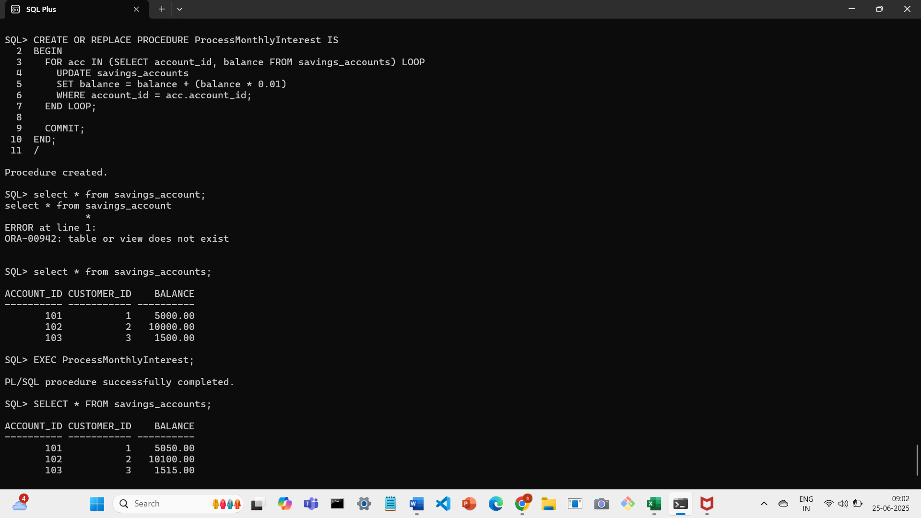

**STEP 2 : Create a procedure that updates the balance of all savings_account by applying an interest of 1%**



**STEP 3 : Output after applying interest**



**Scenario 2:** The bank wants to implement a bonus scheme for employees based on their performance.

**Question:** Write a stored procedure **UpdateEmployeeBonus** that updates the salary of employees in a given department by adding a bonus percentage passed as a parameter.

**STEP 1:Create table employees and insert values**

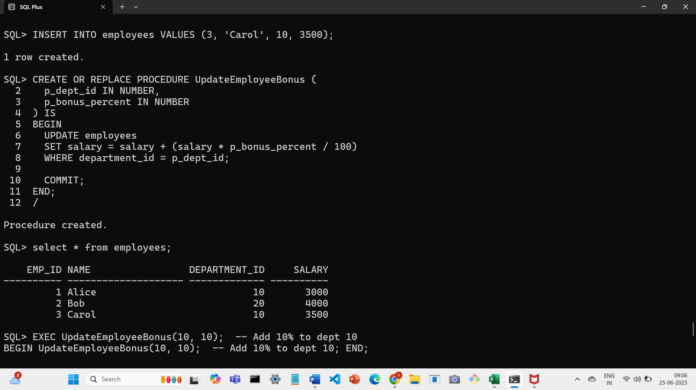

**STEP 2: Create procedure that updates salary of employees by adding a bonus percentage as a parameter**



**STEP 3:Output by adding a bonus percentage as a parameter**

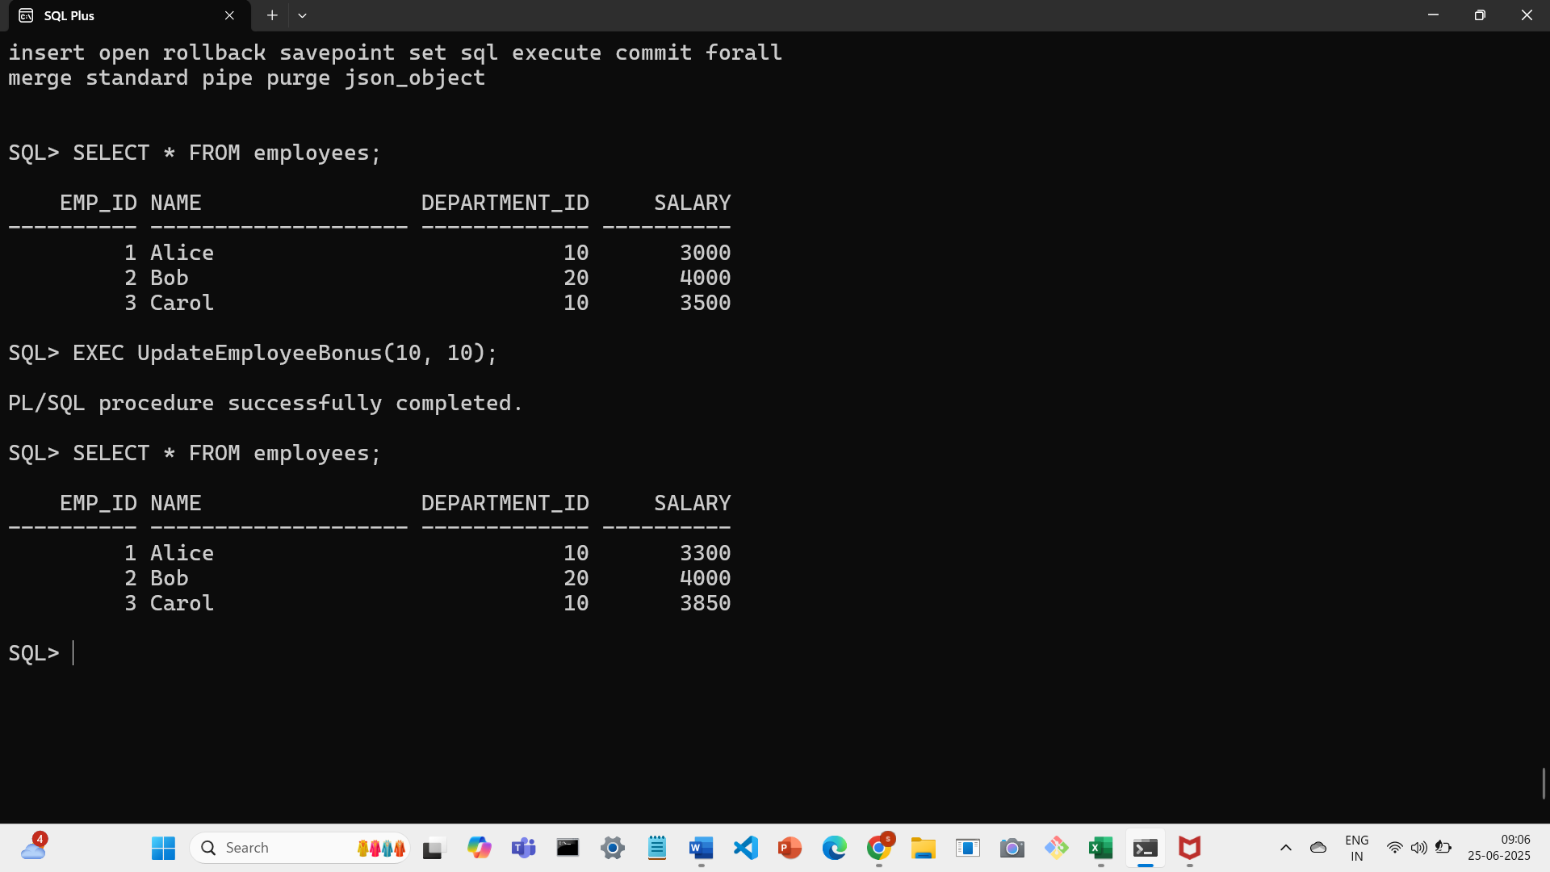

**Scenario 3:** Customers should be able to transfer funds between their accounts.

**Question:** Write a stored procedure **TransferFunds** that transfers a specified amount from one account to another, checking that the source account has sufficient balance before making the transfer.

**STEP 1:Create table accounts and insert values**

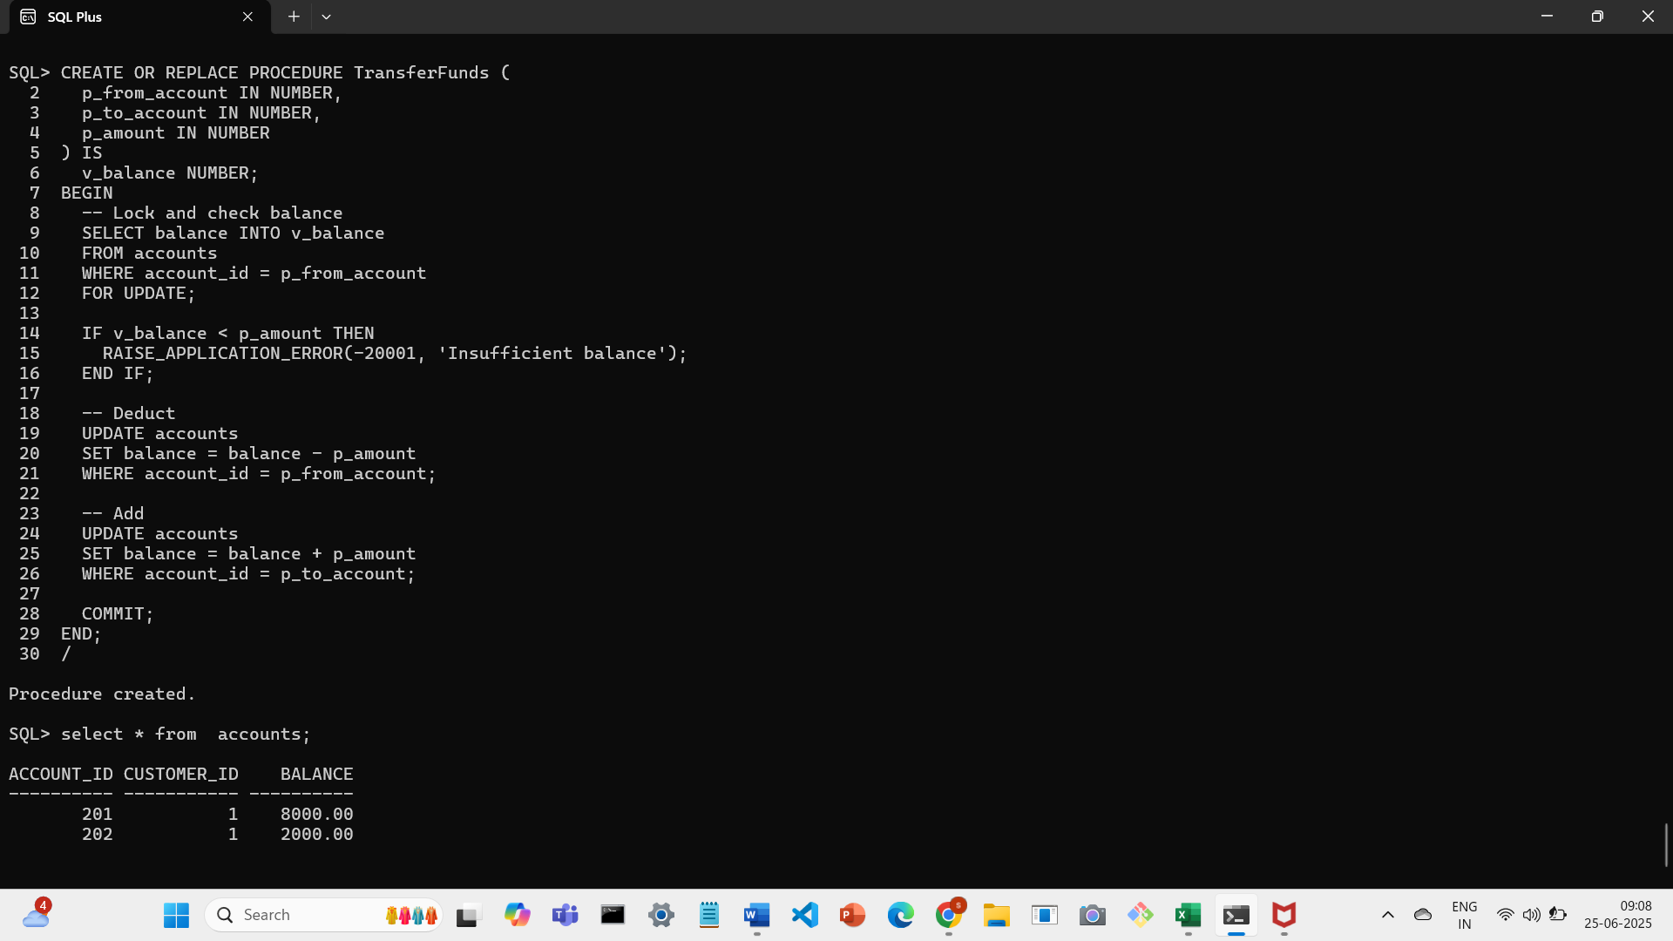

**STEP 2:Create a procedure that transfers a specified amount from one account to another checking the source account has sufficient balance**



**STEP 3:Output and testing the procedure**

